**Yr9 CHEMISTRY REVISION TEST**

**Circle the correct answer:**

1. The nucleus of an atom contains:
2. Neutrons only **b**) electrons only **c)** protons only **d**) protons & neutrons
3. The mass of an atom is found mainly in:
4. Neutrons only **b**)electrons only **c**) protons only **d**) protons & neutrons
5. When an atom gains or loses electrons it becomes:
6. A molecule **b**) an isotope **c**) an ion  **d** ) an element
7. Which statement(s) is/are true:
8. An element has atoms of one type only
9. An positive ion forms when an atom gains protons
10. A negative ion forms when an atom loses electrons
11. A compound forms when two positive ions of different elements join.
12. An atom with the electron configuration 2 electrons in its first shell, 8 electrons in its second shell, and four in its third shell would be the element:
13. Oxygen **b)** Silicon **c)** Carbon **d)** Lithium

**SHORT ANSWER QUESTIONS:**

1. Fill in the blanks below:

“ A neutral atom will always have the same number of electrons as _protons_. In fact it is the number of _protons__________ that determines its atomic number. When an atom gains electrons, it forms a _negatively____ charged ion. Positive ions form when atoms _loses______ electrons.

1. 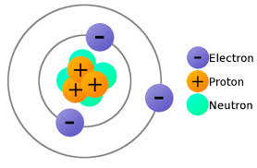In the space below draw an atom of Oxygen, showing all the protons, neutrons and electrons. The diagram of lithium is shown as an example. In your diagram label the protons, neutrons, electrons, and nucleus.

Proton (8)

Neutron (8)

Electron (8)

Nucleus

Example – Lithium atom (unlabelled)

1. Fill in this table:

|  |  |  |  |  |  |  |  |
| --- | --- | --- | --- | --- | --- | --- | --- |
| ELEMENT | SYMBOL | ATOMIC NUMBER | ATOMIC MASS | Number of PROTONS | Number of NEUTRONS | Number of ELECTRONS | ION FORMED |
| Magnesium | Mg | 12 | 24 | 12 | 12 | 12 | Mg+2 |
| Sodium | Na | 11 | 23 | 11 | 12 | 11 | Na+1 |
| Oxygen | O | 8 | 16 | 8 | 8 | 8 | O-2 |
| Aluminium | Al | 13 | 27 | 13 | 14 | 13 | Al +3 |

1. Draw crosses on the circles below to show the electron arrangements of Magnesium and Carbon below. Write the number of neutrons and protons in the nucleus and the configuration on the line below.













Electron Arrangement: 2, 8, 2 (12 electrons) Electron Arrangement: 2, 4 (6 electrons)

1. Write down the name of the elements and how many there are in each of these compounds:

Example: H2O = 2 x hydrogen; 1 x oxygen

1. Calcium Chloride Ca Cl2 = 1 x Calcium, and 2 x Chlorine atoms
2. Aluminium Sulphate Al2 (SO4)3 = 2 x Aluminium, 3 x Sulphur, and 12 x Oxygen atoms
3. 3 molecules of Lithium Carbonate 3 Li2 CO3  = 6 x Lithium, 3 x Carbon, and 9 x Oxygen atoms
4. Given the following reaction:

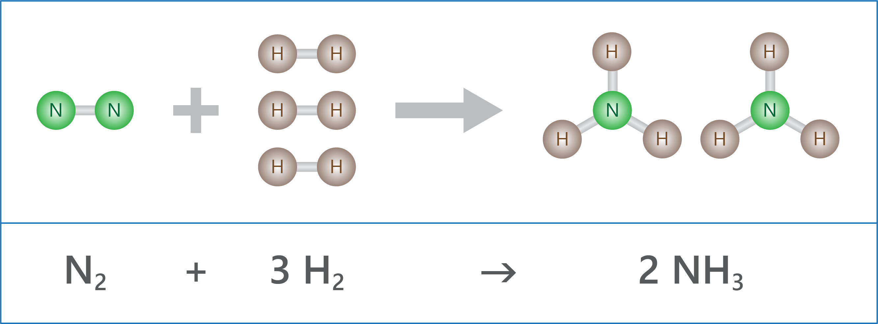**Reaction A**

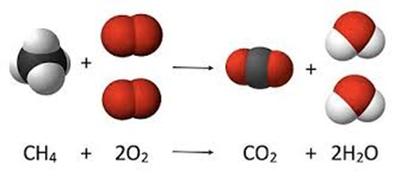**Reaction B**

1. For each reaction list the reactants and the products:

Reaction A - Reactants = N2 and H2  Products = NH3

Reaction B - Reactants = CH4 and O2 Products = CO2 and H2O

1. For each of the reaction list the bonds that are broken in the reactants and the new bonds which are formed to make the products.

Reaction A - Bonds broken = N-N (1) and H- H (3) Bonds formed = N-H (6)

Reaction B - Bonds broken = C-H (4) and O-O (2) Bonds formed = C-O (4) and O-H (4)

1. For each of the following chemical reaction indicate if the reaction is exothermic or endothermic.
2. C6H12O6 + 6O2 → 6CO2 + 6H2O + energy exothermic
3. HC2H3O2 + NaHCO3 + energy → NaC2H3O2 + H2O + CO2 endothermic
4. lime + carbon dioxide ---> calcium carbonate (temp increases) exothermic
5. ammonium nitrate ---> water and dinitrogen oxide (temp decreases) endothermic
6. Explain how a combustion reaction is similar to an oxidation reaction. Explain how the two types of reactions are different to each other.

Combustion and Oxidation reactions are similar because both reactions involve something reacting with oxygen gas (usually from the air). Combustion and Oxidation reactions are different because combustion reactions release a lot of energy and are fast reactions, while oxidation reactions do not release much energy and they are slow reactions.

1. Explain the role that Photosynthesis and Respiration reactions play in your life.

Photosynthesis is a reaction in plants and it has carbon dioxide and water as reactants, and these react to produce Oxygen and starch. The oxygen is important for living things to breathe, and the starch is “plant food” and is the food which all living things depend upon.

Respiration occurs in all living things, and it has oxygen and glucose (simple starch) as reactants, and it produces carbon dioxide and water, and energy is released. Living things use the energy release to run their bodies. If you cannot respire you will die.

Together Photosynthesis and respiration provide a cycle through which oxygen and energy is passed through our ecosystems.

1. **The consequences of increased CO2 in our air include acidification of seawater and a decrease in carbonate ion (CO32-) concentration. The early life stages of invertebrates, such as squid, may be particularly vulnerable to changes in carbon dioxide levels**

**In order to determine how increased levels of carbon dioxide affect the development of squid, eggs were hatched in two different conditions: normal (380 µatm) and elevated (2100 µatm) levels of CO2. The time to hatch and the size of the larvae were measured and recorded. Two trials were conducted for each carbon dioxide concentration.**

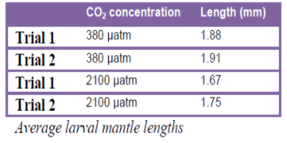

Table showing larval length

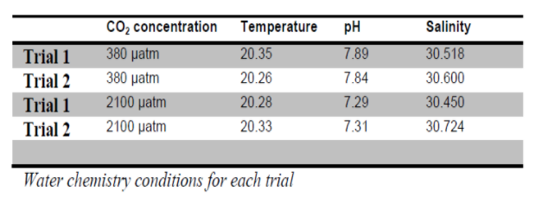

General table

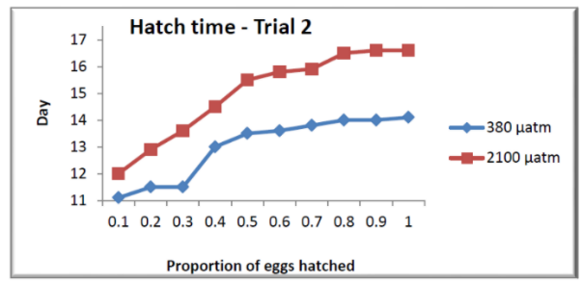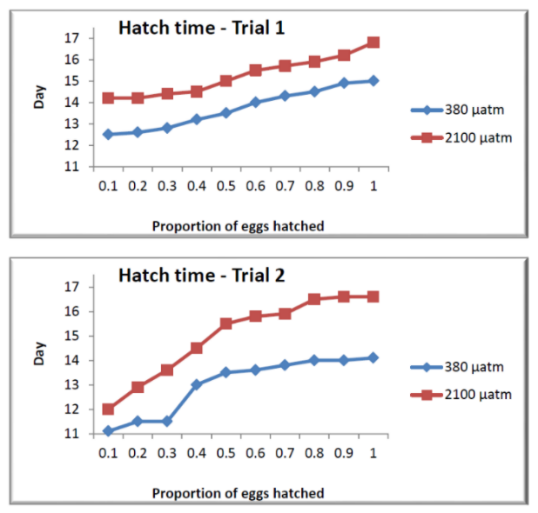

Graphs showing hatching time

Does the data in the tables and graphs above show that increased CO2 in the ocean affects the development of squid eggs? Using the data, explain your reasoning.

The data shows that increased CO2 in the ocean does negatively affect the larvae of squid.

The second table Shows that at higher concentrations of CO2 (2100 µatm), the length of the larvae is less than at lower concentrations of CO2 (380 µatm), meaning larvae are smaller at higher concentrations of CO2. Smaller larvae generally means less well developed larvae.

The two graphs both show that at higher concentrations of CO2, the larvae took longer to hatch (trial 1 they took ~ 2 days longer, and in trial 2 they took ~3 days longer). Larvae which have taken longer to hatch have developed at a slower rate, so hihg CO2 concentrations have a negative effect on larvae hatching.